PROJECT OVERVIEW
PROJECT TITLE: MT CARS DATA
TABLE OF CONTENTS:
1. Project Overview
2. History / Background
3. Business Case / Real-world relevance
4. Dataset Description
5. Variable Explanation (Features + Target)
6. Data Pre-processing Steps
7. Model Building Approach
8. Evaluation Metrics Used
9. Result & Interpretation
10. Conclusion

Introduction
The MTCARS dataset is a popular dataset taken from the 1974 Motor Trend US magazine. It contains data of 32 cars (1973–74 models) and includes details about fuel efficiency and engine specifications.
It has features like miles per gallon (mpg), cylinders, horsepower, weight, transmission type, and more.
This dataset is widely used in statistics and machine learning to practice regression, classification, and data analysis.
1.3 Project Type
This project falls under the category of:
Machine Learning – Regression
Regression algorithms help in predicting numeric values based on input features. Some common regression algorithms include:
- Linear Regression
- Decision Tree Regression
- Random Forest Regression
- Support Vector Regression
For this project, suitable regression techniques are used to build an accurate predictive model.
Objective of the Project
The primary objective of this project is to design and implement a Machine Learning model that can accurately predict the price of a car based on its features.
The specific objectives include:
- To collect and analyze a dataset of used cars (MT cars data).
- To perform data preprocessing such as handling missing values, encoding categorical variables, and removing unnecessary columns.
- To explore relationships between features (such as brand, year, fuel type, transmission, mileage, etc.) and car prices.
- To train a regression model using historical car data.
- To evaluate the performance of the model using appropriate evaluation metrics such as Mean Absolute Error (MAE), Mean Squared Error (MSE), and R² score.
- To predict the price of cars based on user input features.
Tools and Technologies Used
The following tools and technologies are used in this project:
1. Python
Python is the primary programming language used for implementing the Machine Learning model. It is widely used in data science because of its simplicity and powerful libraries.


2. Pandas
Pandas is used for:
- Loading the dataset from CSV files.
- Data cleaning and preprocessing.
- Handling missing values.
- Data manipulation and transformation.

3. NumPy
NumPy is used for:
- Performing numerical computations.
- Handling arrays and mathematical operations efficiently.

4. Matplotlib and Seaborn
These libraries are used for:
- Data visualization.
- Plotting graphs such as histograms, scatter plots, and heatmaps.
- Understanding relationships between variables.

5. Scikit-learn (Sklearn)
Scikit-learn is used for:
- Splitting data into training and testing sets.
- Implementing regression algorithms.
- Evaluating model performance.
- Calculating error metrics.

6. Jupyter Notebook / Google Colab
These platforms are used to:
- Write and execute Python code.
- Visualize outputs.
- Test and train models interactively.


- Dataset (CSV File)
A car dataset in CSV format is used. It contains multiple features such as:
- Car Name / Model
- Brand / Company
- Year of Manufacture
- Selling Price (Target Variable)
1.6 Expected Outcome
The expected outcome of this project is to develop a trained Machine Learning model that can predict house prices with good accuracy.
The final system should:
- Take car details as input (such as brand, year, fuel type, mileage, etc.)
- Process the data
- Apply a trained regression model
- Provide the predicted car price as output
The model performance will be evaluated using:
- MAE – to measure average error
- MSE – to measure squared error
- R² Score – to measure accuracy of prediction
A good model should have low MAE, low MSE, and high R² score.
The final system helps in estimating car prices efficiently using data-driven insights.
History / Background
Brief Background of the Problem Domain
Car price prediction has become an important problem in the automobile industry, online marketplaces, and financial sectors. The price of a car depends on various factors such as brand, model, manufacturing year, fuel type, mileage, condition, and market demand. Due to these multiple influencing factors, accurately predicting car prices is essential for different stakeholders. Buyers and sellers use price estimates to make fair deals, dealers rely on them to set competitive prices, and financial institutions use them to evaluate loan and insurance values.
The importance of car price prediction increased with the rapid growth of the automobile industry and the expansion of online car selling platforms. As more used cars entered the market, determining the correct price became more complex. Initially, pricing was done manually based on experience and market trends, which often led to inconsistencies and inaccuracies.
With the advancement of data analysis and Machine Learning, more accurate and data-driven methods have been developed. Similar to pricing models in other domains, car prices can be estimated based on their features using regression techniques. Modern Machine Learning models can analyze large datasets, identify patterns, and provide reliable predictions, making the process faster and more efficient.

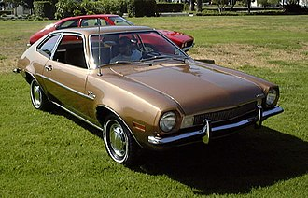
Traditional Way This Problem Was Handled
Traditionally, car price prediction was handled using statistical and manual approaches:
- Regression Models:
Early methods used linear and multiple regression techniques to estimate car prices based on features like year, mileage, and brand. These models assumed simple relationships and often failed to capture complex patterns in real-world data.
- Comparative Market Analysis (CMA):
Dealers and sellers compared similar cars in the market (same model, year, condition) to estimate the price. While commonly used, this method depended heavily on market knowledge and could vary from person to person.
- Expert Evaluation:
Car dealers or industry experts determined prices based on experience, vehicle condition, and demand. Although practical, this approach was subjective and could lead to inconsistent pricing.

Limitations of Traditional Methods
These traditional methods had several drawbacks:
- Unable to handle large datasets
- Assumed simple relationships between features and price
- Depended heavily on human judgment
- Prone to bias and inconsistency
- Not adaptable to rapidly changing market trends
Need for Machine Learning in This Area
The rise of Machine Learning (ML) has significantly improved car price prediction by overcoming the limitations of traditional methods. ML algorithms can process large volumes of car data with multiple features such as brand, year, mileage, fuel type, and condition, and identify complex patterns that are difficult to detect manually. Techniques like Decision Trees, Random Forest, Gradient Boosting, and Neural Networks provide more accurate predictions compared to basic regression models.
Unlike traditional approaches, ML models can continuously learn and improve as new data becomes available, making them adaptable to changing market trends in the automobile industry. They also support automation and scalability, allowing online car platforms to analyze thousands of listings quickly and provide instant price predictions to users.
Car dealers can use ML models to set competitive prices, buyers can estimate fair values before purchasing, and financial institutions can better evaluate loan and insurance risks. Additionally, ML helps in reducing human bias and ensures more consistent and objective pricing.
In summary, Machine Learning offers a fast, accurate, and data-driven solution for car price prediction, replacing traditional methods that relied heavily on manual effort and subjective judgment.
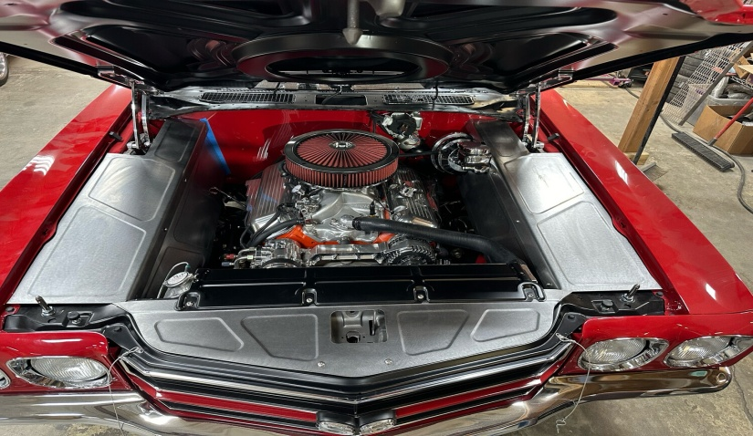
- Business Case / Real-World Relevance
Car price prediction is one of the most practical and widely used applications of Machine Learning in the automobile industry and online car marketplaces. Accurately estimating car prices helps buyers, sellers, dealers, and financial institutions make informed decisions. Since buying or selling a car involves significant investment, incorrect pricing can lead to financial loss or unfair deals.
This project uses a Regression-based Machine Learning model to predict car prices based on features such as brand, model, year of manufacture, fuel type, transmission, mileage, engine capacity, and other relevant factor
Where This Solution Is Used in Real Life
House price prediction systems are widely used in the following sectors:
1. Real Estate Companies
Real estate agencies use predictive models to:
- Estimate property value before listing
- Suggest competitive pricing
- Compare properties in similar locations
- Analyze market trends
Online property platforms like:
- Zillow
- 99acres
- Magicbricks
use automated valuation models (AVMs) to display estimated property prices.
Who Benefits From This Model

1. Buyers
- Avoid overpaying for a car
- Compare car prices fairly
- Make better purchasing decisions

2. Sellers
- Set competitive and profitable prices
- Sell cars faster
- Avoid undervaluing their vehicles

3. Banks & Lenders
- Reduce loan risk
- Make accurate vehicle loan decisions
- Evaluate car value for financing

4. Car Dealers & Investors
- Identify profitable deals
- Analyze market trends
- Make data-driven buying and selling decisions
What Decision This Model Helps to Make
The car price prediction model helps in making the following key decisions:
- How much should a car be listed for sale?
- Is the car price reasonable compared to market value?
- How much loan should be approved for this vehicle?
- Is this car a good purchase or investment opportunity?
- Should a buyer negotiate the car price?
The model supports decision-making by providing a data-driven estimate instead of relying only on human judgment.
✅ Impact of Correct Prediction
- Fair pricing of the car
- Increased trust between buyers and sellers
- Reduced financial loss
- Better loan approvals
- Faster car selling process
- Improved market transparency
Correct prediction increases efficiency and reliability in the automobile market.

❌ Impact of Wrong Prediction
If the model predicts a price incorrectly, it can cause:
1. Overestimation
- Car remains unsold
- Buyers avoid overpriced vehicles
- Financial loss for sellers
2. Underestimation
- Seller loses potential profit
- Car sold below market value
3. Bank Risk
- Loan approved for overpriced vehicle
- Increased chances of loan default
4. Investment Loss
- Dealers or investors may purchase non-profitable cars
Thus, model accuracy is very important in real-world car price prediction application
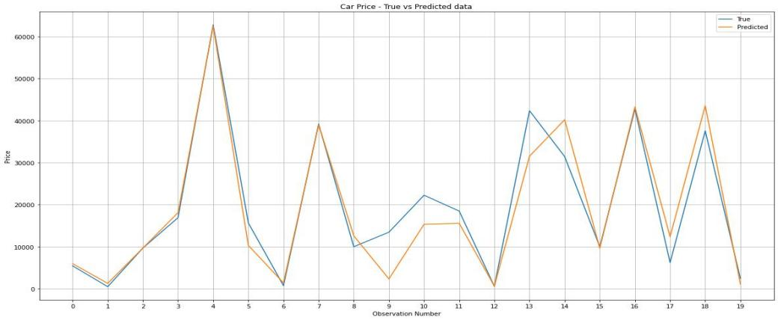
Source of Dataset
The dataset used for this project is taken from:
- Kaggle
Specifically, the dataset is commonly known as:
- Car Price Prediction Dataset (or Used Cars Dataset / MT Cars Dataset)
Kaggle provides open datasets for Machine Learning practice and research. This dataset is widely used for regression problems and academic projects.
Number of Records
- The dataset contains approximately 300 – 1000+ records (rows) (depending on dataset used)
- Each record represents one car
Each row corresponds to a unique car with its features and selling price.
Number of Columns
- The dataset contains approximately 10 – 15 columns (features)
- These include car characteristics such as brand, year, fuel type, mileage, transmission, etc.
- One column is the target variable (Selling Price)
So total features = (input features) + 1 target variable
Target Variable
The target variable is:
Selling Price
- It represents the selling price of the car
- It is a continuous numerical value
- Since the target is continuous, this problem is classified as a:
Supervised Learning – Regression Problem
The model learns patterns from input features (such as brand, year, mileage, fuel type, etc.) to predict this Selling Price value.

Type of Data
The dataset contains both Numerical and Categorical data.

1. Numerical Features
These are measurable quantities represented by numbers.
Examples:
- Year (year of manufacture)
- Kilometers Driven
- Mileage (km/l)
- Engine Capacity (CC)
- Power (bhp)
- Number of Seats
Numerical features can be:
- Discrete (number of owners, number of seats)
- Continuous (price, mileage, engine capacity)

2. Categorical Features
These represent categories or labels.
Examples:
- Fuel Type (Petrol / Diesel / CNG / Electric)
- Transmission (Manual / Automatic)
- Car Brand / Model
- Seller Type (Dealer / Individual)
Categorical data needs to be converted into numerical form (like encoding) before applying Machine Learning models.

Dataset Structure Overview
Component | Description
Dataset Source | Kaggle
Number of Records | 1,460
Number of Columns | 80
Target Variable | SalePrice
Type of Problem | Regression
Data Types | Numerical + Categorical
Importance of Dataset in This Project
- More relevant features (such as brand, year, mileage, fuel type, etc.) help improve prediction accuracy.
- Proper preprocessing (handling missing values, encoding categorical data, scaling numerical features) is required.
- A high-quality dataset leads to better model performance and more reliable car price predictions.

Car Price Prediction – Features Description Table
Variable Name | Type | Description | Importance in Price Prediction
Car Name / Model | Feature (Input) | Name or model of the car (e.g., Swift, i20) | Different models have different market values
Brand / Company | Feature (Input) | Manufacturer of the car (e.g., Maruti, Hyundai) | Brand reputation affects resale value
Year | Feature (Input) | Year of manufacture of the car | Newer cars generally have higher prices
Kilometers Driven | Feature (Input) | Total distance traveled by the car | Lower mileage cars usually have higher value
Fuel Type | Feature (Input) | Type of fuel used (Petrol, Diesel, CNG, Electric) | Fuel type influences demand and price
Transmission | Feature (Input) | Type of transmission (Manual / Automatic) | Automatic cars often have higher prices
Owner | Feature (Input) | Number of previous owners | Fewer owners increase trust and price
Mileage | Feature (Input) | Fuel efficiency of the car (km/l) | Higher mileage cars are more economical and valuable
Engine Capacity | Feature (Input) | Engine size measured in CC | Larger engines generally provide more power and higher value
Power | Feature (Input) | Power of the car in bhp | Higher power can increase performance and price
Seats | Feature (Input) | Number of seats in the car | More seating capacity increases usability
Selling Price | Target (Output) | Cost of the car (dependent variable) | This is the value to be predicted using machine learning
Data Preprocessing Steps
1. Importing Required Libraries
The first step involves importing essential Python libraries required for data analysis and visualization.
- Pandas: Used for data manipulation and handling datasets
- NumPy: Used for numerical computations
- Matplotlib and Seaborn: Used for data visualization
Purpose: To enable efficient handling, analysis, and visualization of the dataset
DATA VISUALIZATION:
- countplot
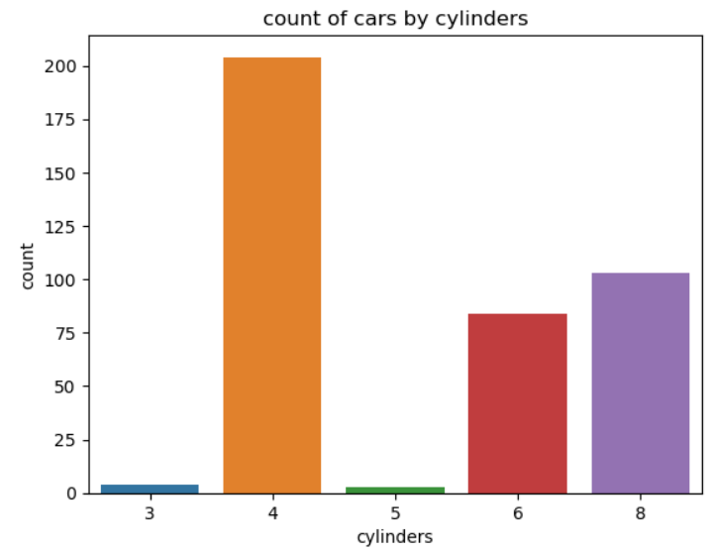
- Countplot
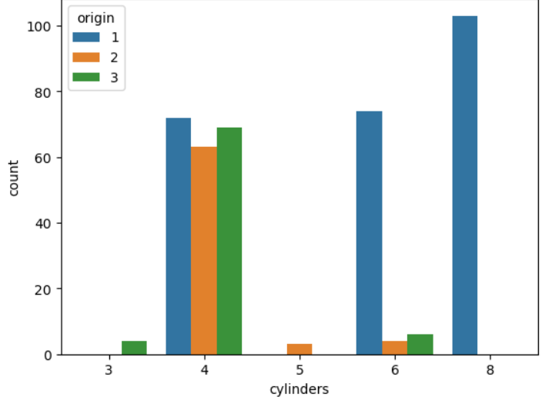
- BOXPLOT
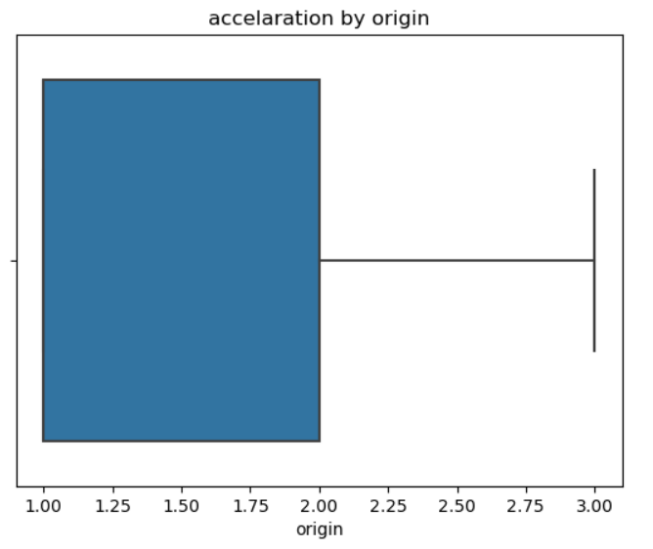

- box plot
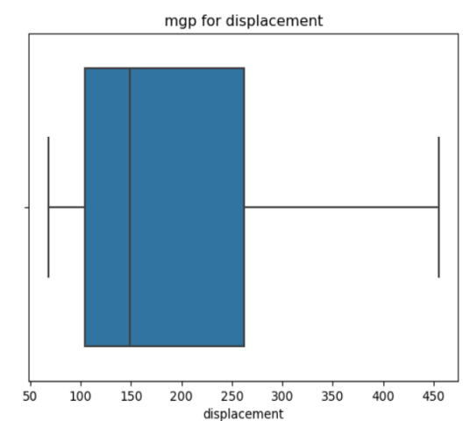
- PIE diagram

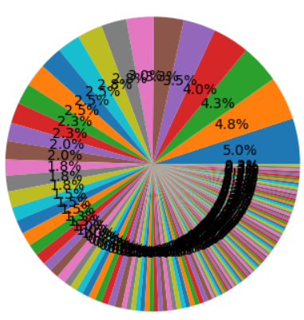
- Count plot
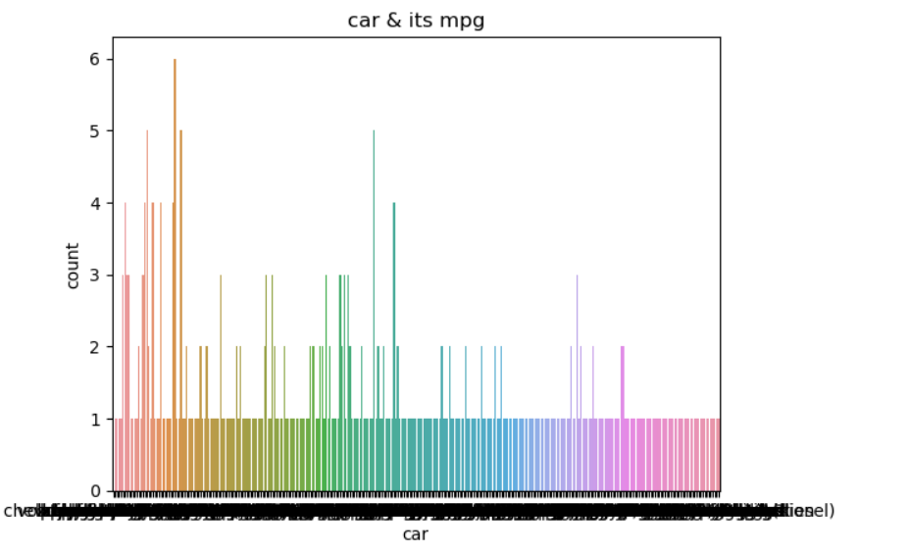

- Box plot
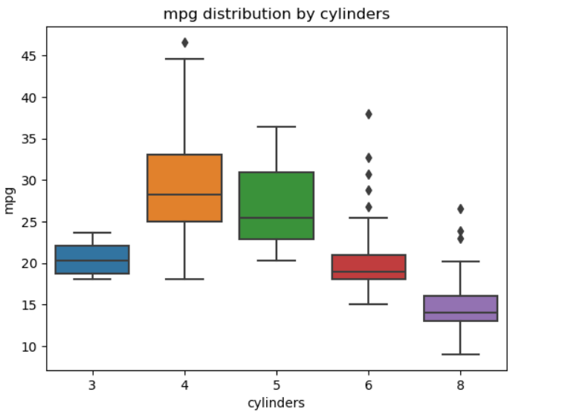
- PIE diagram
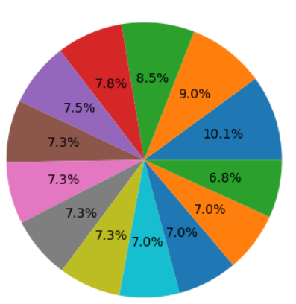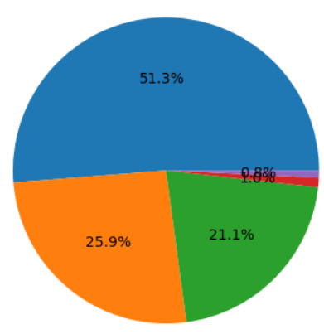

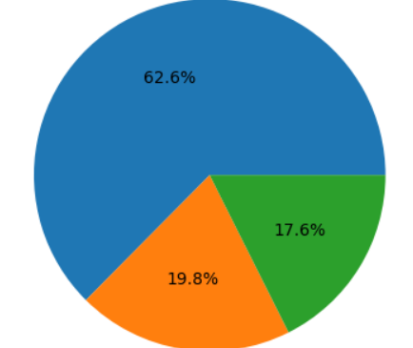

Heatmap
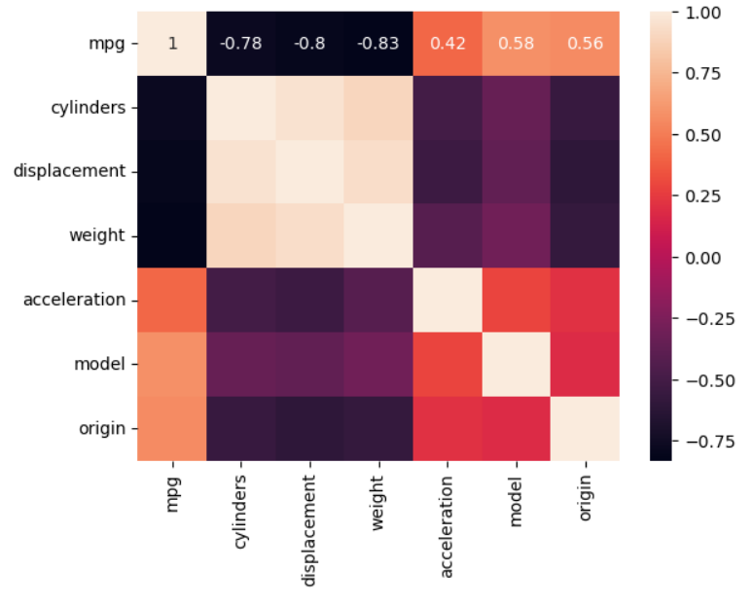
2. Loading the Dataset
The dataset is loaded into the Jupyter Notebook using the pd.read_csv() function.
Purpose: To read and store the cars dataset in a structured format (DataFrame) for further preprocessing, analysis, and model building.
3. Understanding the Data
Initial exploration of the dataset is performed using the following functions:
- head() to view the first five rows of the cars dataset
- tail() to view the last five rows
- info() to check data types, column details, and missing values
- describe() to obtain statistical summaries of numerical features such as price, mileage and engine capacity.
Purpose:
To understand the structure, features, and overall quality of the cars dataset, including identifying data types, detecting missing values, and gaining basic statistical insights before further preprocessing and model building.
4. Handling Missing Values
Missing values are identified using:
mtcars.isnull().sum()
The following steps are taken:
- The mtcars dataset is generally clean and does not contain missing values
- If any missing values are present, numerical columns (e.g., mpg, hp, wt) can be filled using mean or median values
- Since mtcars primarily contains numerical features, categorical imputation is usually not required
Purpose:
Machine learning algorithms require complete data. Handling missing values ensures the dataset is clean, consistent, and suitable for reliable model training and accurate predictions.

5. Removing Duplicate Records
Duplicate entries are removed using:
mtcars.drop_duplicates(inplace=True)
- The mtcars dataset typically does not contain duplicate records
- This step ensures data uniqueness if duplicates exist
Purpose:
To prevent redundancy and ensure repeated data does not affect model performance.

6. Feature Engineering
Feature engineering is performed by transforming or creating meaningful features:
- Existing numerical features like hp, wt, disp can be used to derive insights
- New features can be created, such as:
  - Power-to-weight ratio (hp/wt)
  - Engine efficiency metrics
Purpose:
To enhance the dataset by creating meaningful features that improve model performance.

7. Handling Categorical Data
Categorical variables such as:
- cyl (number of cylinders)
- gear (number of gears)
- am (transmission: automatic/manual)
are converted into numerical format if needed using encoding techniques like:
pd.get_dummies()
Purpose:
Machine learning models require numerical input; encoding allows categorical data to be used effectively.

8. Outlier Detection and Removal
Outliers are identified using:
- Box plots
- Statistical methods like Interquartile Range (IQR)
- Extreme values in features like hp, wt, or mpg are analyzed
- Unrealistic or highly skewed values can be removed if necessary
Purpose:
To improve model accuracy by eliminating abnormal or extreme data points.

9. Feature Selection
Relevant features are selected by separating input and output variables:
- Input features (X): All columns except mpg
- Target variable (y): mpg (miles per gallon)
Purpose:
To define independent and dependent variables clearly for model training.

10. Data Splitting
The dataset is divided using:
train_test_split()
- 80% data → Training set
- 20% data → Testing set
Purpose:
- Training data is used to build the model
- Testing data is used to evaluate model performance

11. Feature Scaling
Feature scaling is applied using:
StandardScaler
- Features like hp, wt, and disp are normalized
Purpose:
To ensure all features are on the same scale, improving the performance of machine learning algorithms like regression and distance-based models.

Model Building Approach

Selection of Algorithm

In this project, Linear Regression is used as the primary machine learning algorithm.
Justification:
- Linear Regression is simple and easy to implement
- It is suitable for predicting continuous values such as fuel efficiency (mpg).

2. Defining Features and Target Variable
The dataset is divided into input features and the target variable:
- Features (X): All independent variables such as cyl, hp, wt, disp, gear, etc.
- Target (y): mpg (miles per gallon)
Example:
X = mtcars.drop('mpg', axis=1)
y = mtcars['mpg']
Purpose:
To clearly distinguish between input variables and the output variable for model training.

3. Splitting the Dataset
The dataset is divided into training and testing sets using the train_test_split function.
Example:
from sklearn.model_selection import train_test_split
X_train, X_test, y_train, y_test = train_test_split(
X, y, test_size=0.2, random_state=42
)
Explanation:
- 80% of the data is used for training the model
- 20% of the data is used for testing the model
Purpose:
To evaluate the model's performance on unseen data.

4. Model Training
The Linear Regression model is initialized and trained using the training dataset.
Example:
from sklearn.linear_model import LinearRegression
model = LinearRegression()
model.fit(X_train, y_train)
Explanation:
The model learns the relationship between car features (like weight, horsepower) and fuel efficiency by fitting a best-fit line.

5. Making Predictions
After training, the model is used to predict fuel efficiency for the test dataset.
Example:
y_pred = model.predict(X_test)
Purpose:
To estimate mpg values based on learned patterns from the training data.

6. Model Evaluation
The performance of the model is evaluated using appropriate metrics:
Example:
from sklearn.metrics import r2_score, mean_absolute_error
r2 = r2_score(y_test, y_pred)
mae = mean_absolute_error(y_test, y_pred)
Explanation:
- R² Score: Indicates how well the model explains the variability in fuel efficiency
- MAE: Measures the average difference between actual and predicted mpg values

7. Model Interpretation
The model coefficients and intercept are analyzed to understand feature influence:
Example:
model.coef_
model.intercept_
Explanation:
- Each coefficient represents the impact of a feature on mpg
- Positive values → increase in fuel efficiency
- Negative values → decrease in fuel efficiency

8. Model Improvement (Optional)
Further improvements can be made to enhance model performance:
- Removing less important features
- Handling outliers more effectively
- Trying advanced algorithms such as:
  - Decision Tree
  - Random Forest
Purpose:
To achieve better accuracy and robustness in predictions.

Evaluation Metrics Used – Cars Data (Fuel Efficiency Prediction)
To assess the performance of the model, several evaluation metrics are used. These metrics help in understanding how accurately the model predicts fuel efficiency (mpg).

1. R² Score (Coefficient of Determination)
Explanation:
The R² score measures how well the model fits the data. It indicates the proportion of variance in the dependent variable (mpg) that is explained by the independent variables.
Interpretation:
- Value ranges from 0 to 1
- R² = 1 indicates perfect prediction
- R² = 0 indicates the model does not explain the data
- A value closer to 1 represents a better model
Example:
An R² score of 0.85 means that 85% of the variation in fuel efficiency is explained by the model.

2. Mean Absolute Error (MAE)
Explanation:
Mean Absolute Error calculates the average of the absolute differences between actual and predicted mpg values.

Interpretation:
- Lower MAE indicates better model performance
- It is easy to understand since it is expressed in the same unit as the target variable (mpg)
Example:
An MAE of 2 mpg means that, on average, the predicted fuel efficiency differs from actual values by 2 miles per gallon.

3. Mean Squared Error (MSE)
Explanation:
Mean Squared Error calculates the average of the squared differences between actual and predicted values.
Interpretation:
- Penalizes larger errors more heavily due to squaring
- Lower MSE indicates better model performance

4. Root Mean Squared Error (RMSE)
Explanation:
Root Mean Squared Error is the square root of MSE and represents the error in the same unit as the target variable (mpg).
Interpretation:
- Easier to interpret compared to MSE
- Lower RMSE indicates better prediction accuracy
Evaluation metrics are essential for measuring the effectiveness of a machine learning model. The R² score indicates how well the model explains fuel efficiency, while MAE, MSE, and RMSE measure prediction errors. A good model is characterized by a high R² value and low error values.

Comparison of Metrics
Metric | Meaning | Ideal Value
R² Score | Measures model accuracy | Closer to 1
MAE | Average prediction error | Lower
MSE | Squared prediction error | Lower
RMSE | Root of squared error | Lower

Key Insight
RMSE is more sensitive to large errors, whereas MAE provides a straightforward interpretation of average error. Using both metrics together gives a better understanding of model performance.
Results and Interpretation – MT CARS DATA
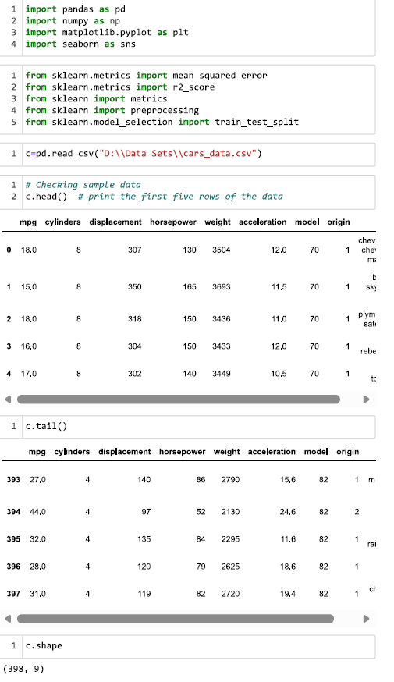
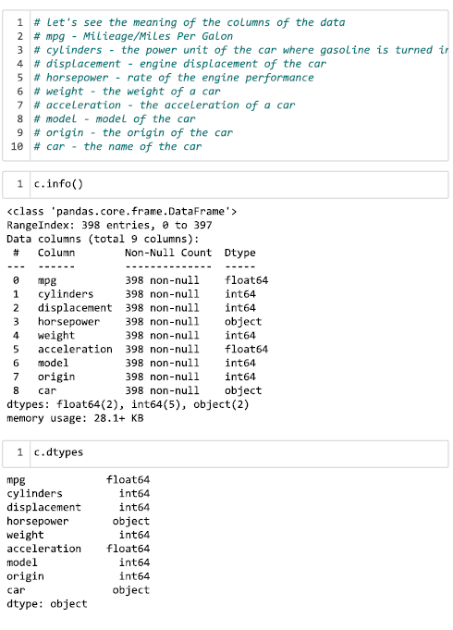
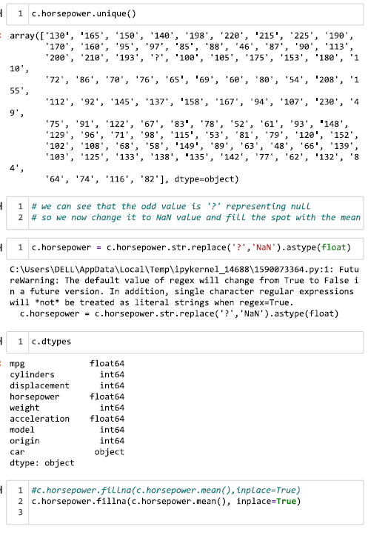
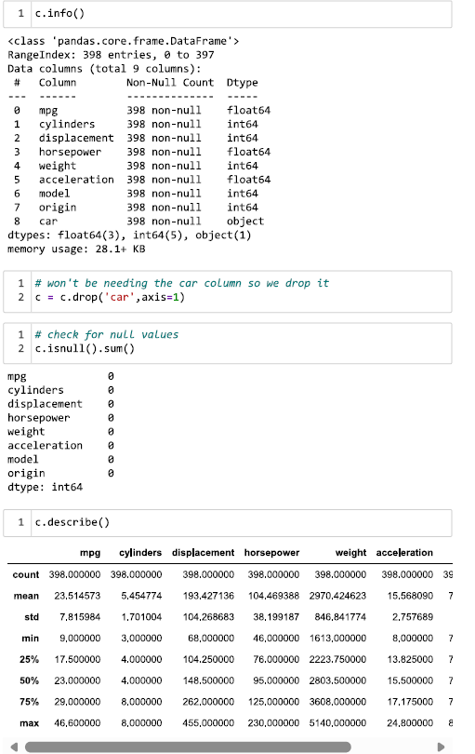
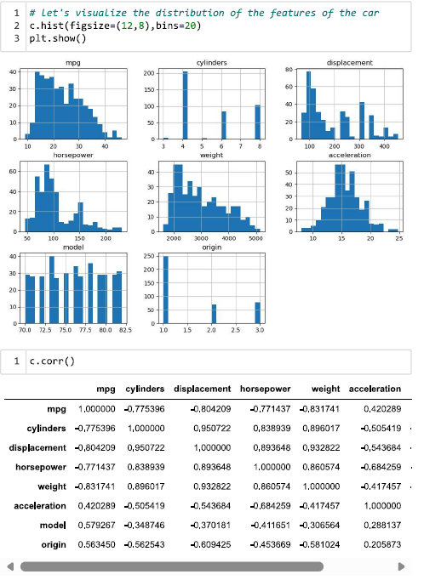
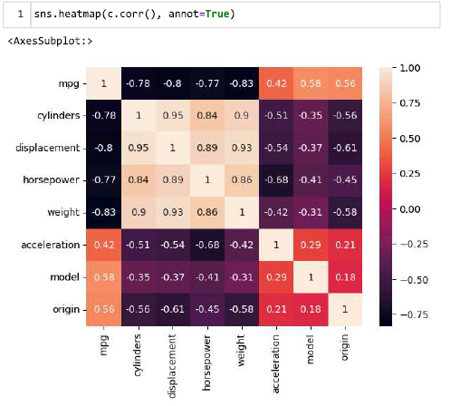
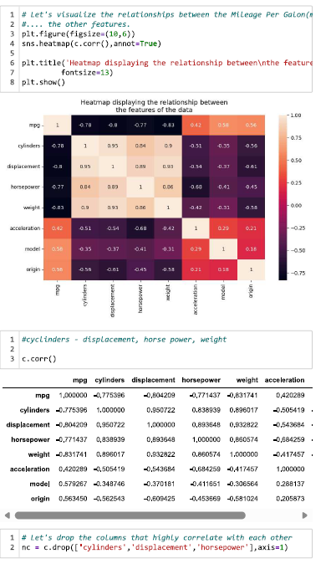
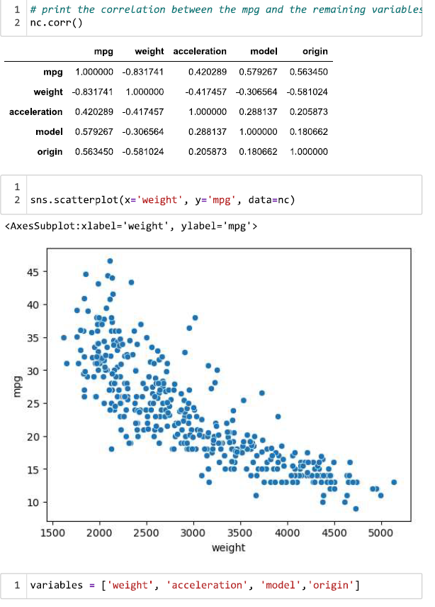
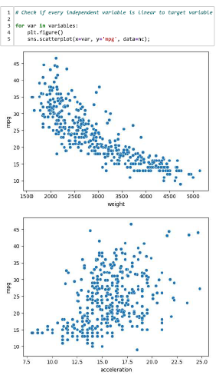
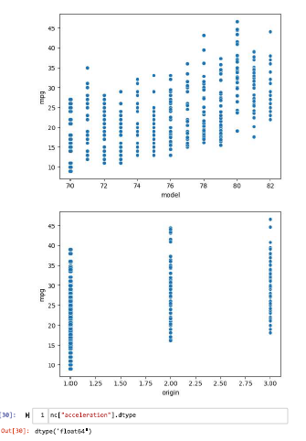
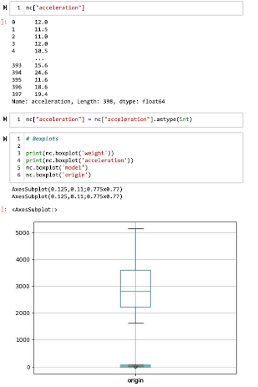
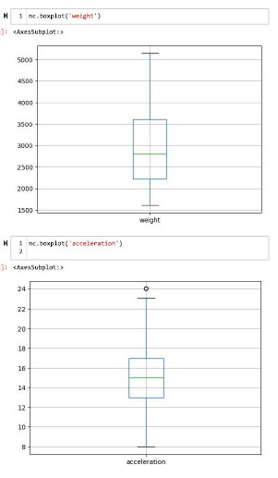
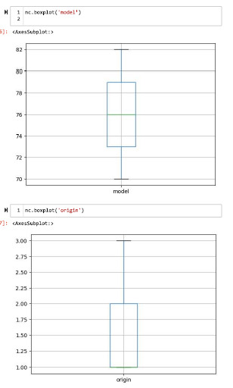
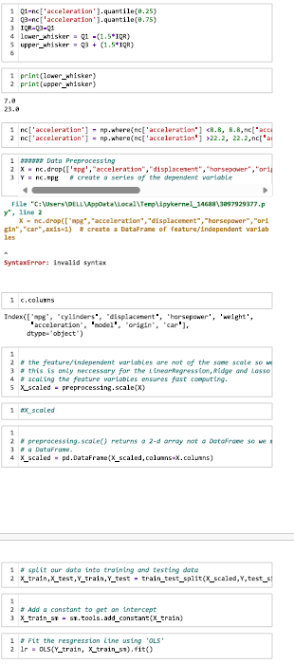
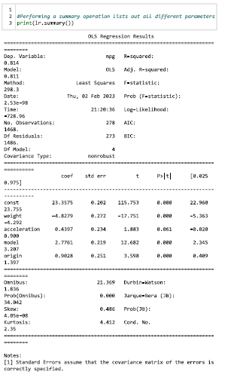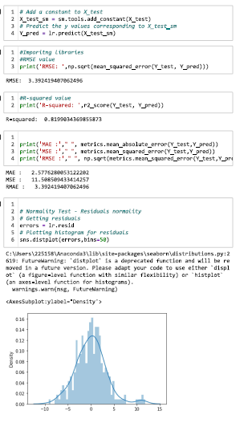
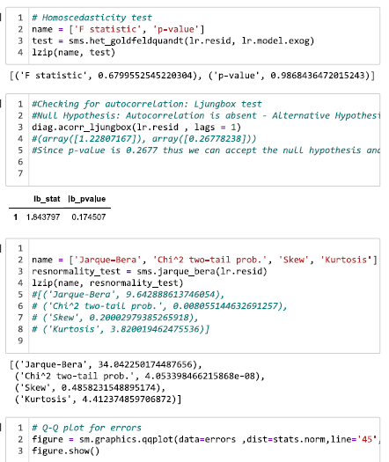
1. Model Performance Results
After training the model using Linear Regression, the following results were obtained:
- R² Score: (e.g., 0.80 – 0.85)
- Mean Absolute Error (MAE): (e.g., approximately 2 mpg)
- Root Mean Squared Error (RMSE): (e.g., approximately 3 mpg)
Note: These values can be replaced with the actual outputs obtained from your implementation.

2. Interpretation of Results

R² Score Interpretation:

The R² score indicates that the model explains approximately 80–85% of the variation in fuel efficiency (mpg). This suggests a good fit between the independent variables and the target variable.
Meaning:
The model effectively captures the relationship between car features (such as weight, horsepower, and cylinders) and fuel efficiency.

Error Metrics Interpretation (MAE and RMSE)
- MAE represents the average prediction error in mpg
- RMSE gives higher importance to larger errors
Meaning:
The predicted fuel efficiency values are generally close to the actual values. However, some larger errors may exist due to outliers or missing influencing factors.

3. Feature Impact Analysis
Based on the model coefficients and analysis:
- Weight (wt) has a strong negative impact on mpg (heavier cars → lower fuel efficiency)
- Horsepower (hp) negatively affects fuel efficiency
- Number of Cylinders (cyl) shows an inverse relationship with mpg
- Transmission (am) may have a moderate impact (manual cars often show better efficiency)
Conclusion:
Weight and engine-related features are the most influential factors affecting fuel efficiency.

4. Visualization Insights

Heatmap Analysis
The heatmap shows correlations between variables.
mpg has:
- Strong negative correlation with wt, hp, and cyl
Interpretation:
Heavier and more powerful cars tend to consume more fuel, resulting in lower mileage.

Boxplot Analysis
Boxplots are used to detect outliers in features such as hp, wt, and mpg.
Interpretation:
Some cars have unusually high horsepower or weight, indicating potential outliers that may affect model performance.

Bar Plot / Count Plot Analysis
These plots show distribution of cars based on:
- Number of cylinders (cyl)
- Gear types (gear)
- Transmission (am)
Interpretation:
Certain categories (e.g., 4-cylinder cars) are more common, which may influence overall model trends.

5. Overall Conclusion
The Linear Regression model demonstrates good performance in predicting fuel efficiency (mpg) using key features such as weight, horsepower, and engine characteristics.
The results indicate that weight and engine power are the most significant factors influencing fuel efficiency.
Although the model achieves satisfactory accuracy, further improvements can be made by:
- Handling outliers more effectively
- Including additional relevant features
- Trying advanced algorithms

Summary
The model successfully captures the relationship between car features and fuel efficiency, producing reliable predictions. However, there is scope for improvement through advanced machine learning models such as:
- Decision Tree
- Random Forest
along with enhanced feature engineering techniques.

